 **ALAGAPPA COLLEGE OF TECHNOLOGY**

**ANNA UNIVERSITY-600025**

​​

**NM Assignment / Digital Marketing**

|  |  |  |
| --- | --- | --- |
| **NAME** | **REG.NO** | **Naan Mudhalvan ID** |
| Aishwarya A | 2020308001 | 21BBCB2F796328CBDA24C1B38EEA12A2 |

1. Create a blog or website using Blogpost Customise the theme design and post new article with 500 words.

<https://mindfullbliss.blogspot.com/2023/08/steps-to-mindfulness.html>

2. Create a New Facebook Business Page and post one social media poster for your brand.

<https://www.facebook.com/AAishwarya1804>

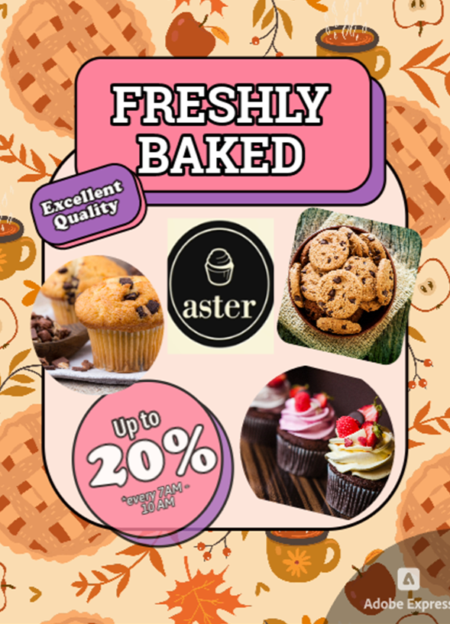3. Create and design a social media advertisement poster using Canva.

4. Create email newsletter design using MailChimp or Canva tool.

